REQUEST FOR EDUCATIONAL RECORDS FORM
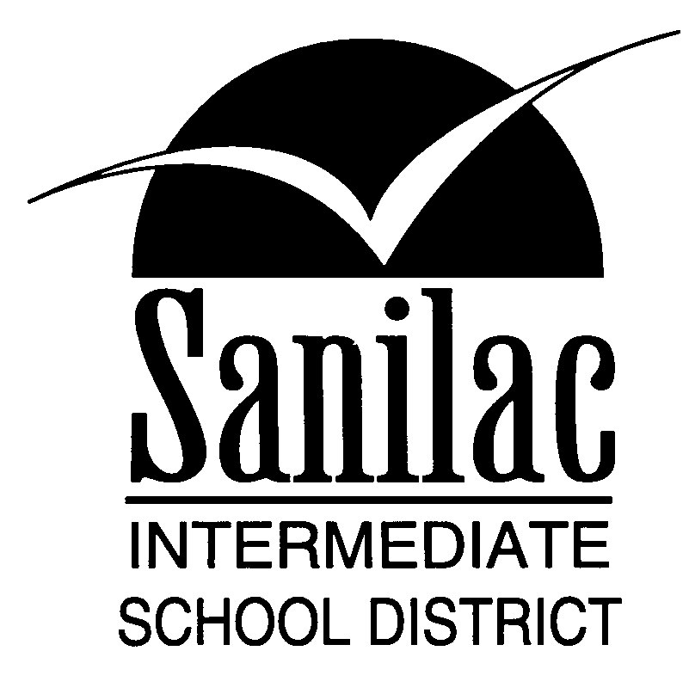
Special Education Services
46 North Jackson Street
Sandusky, Michigan 48471
810-648-2200

I, __________________________________________________________________, hereby
PARENT/STUDENT

authorize_____________________________________________________________________
INDIVIDUAL/AGENCY/DISTRICT

______________________________________________________________________________
ADDRESS CITY STATE Zip

______________________________________________to release any pertinent information on
PHONE AND FAX NUMBER

_______________________________, relating to_____________________________________
STUDENT’S NAME REASON FOR DISCLOSURE

To: __________________________________________________________________

__________________________________________________________________

__________________________________________________________________

__________________________________________________________________
INDIVIDUAL/AGENCY/DISTRICT

I authorize the use of telefax, photocopy and email of this form for the release or disclosure of the information described on this form. I understand that the authorization, except for action already taken, may be voided by me at any time.

I authorize the mutual sharing of information between individuals/agencies/districts.

I authorize the transfer of all school records including the complete CA 60 to the above stated individual/agency/district including all information regarding immunizations, placement, psychological testing, special education files, etc.

SIGNED: _______________________________________ DATE: _______________________
PARENT/STUDENT

